The Security Institute Sign Memorandum of Understanding with SIRA UAE
Day two of this year’s Intersec Dubai exhibition proudly saw Rick Mounfield CSyP FSyI, Chief Executive of The Security Institute, successfully sign an MoU with Brigadier Khalifa Al Salies, Chief Executive Officer of the Dubai-based Security Industry Regulatory Agency.

This development is a big step in the Institute’s global engagement strategy and will allow the SyI Middle-East members group an opportunity to collaborate more closely with SIRA on CPD events and other networking opportunities within Dubai.

Dr Alison Wakefield FSyI took to Twitter to air her delight, saying that the partnership was: “A fantastic development as part of our global engagement. Well done and thanks to our Middle East Members Group, especially the MEMG Chair and former [Security Institute] director, Simon Whitehouse.”

Rick Mounfield CSyP FSyI also expressed: “Our relationship with SIRA marks a new chapter for the Middle East membership based in the UAE. With SIRA’s support and collaboration, we will be able to organise training and CPD activity for the benefit of both our members and the SIRA community.

The professionals in our membership are ready and keen to share knowledge and experience for the improvement of security practices for all. I am looking forward to witnessing the relationship blossom”.
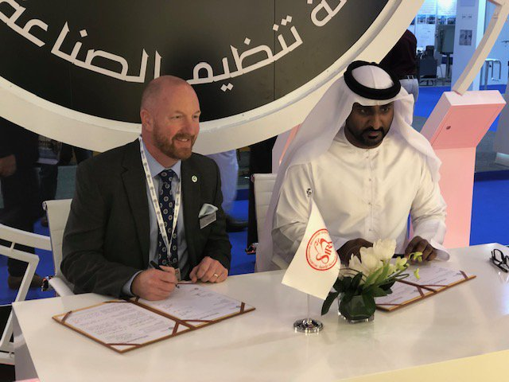
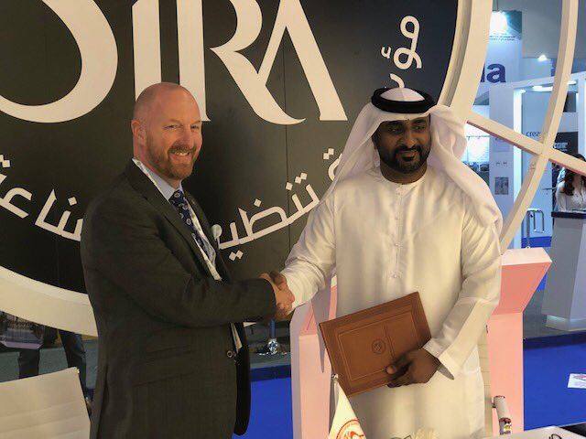

Rick Mounfield CSyP FSyI, Chief Executive of The Security Institute (left) with Brigadier Khalifa Al Salies, Chief Executive Officer of SIRA (right).
Ends.
MARKETING & PR ENQUIRIES
Rachael Short, Marketing & PR Officer
02476 346 758
rachael@security-institute.org
www.security-institute.org
NOTE TO EDITORS
The Security Institute is the UK’s largest professional membership body for security professionals, with over 2,700 members.

Since 2000 the Institute has been working to promote the highest possible standards of integrity and professional competence in the business of security.

Membership of The Security Institute gives credibility, enhances career prospects, provides a network of excellent contacts, and offers continual professional development and a wide range of networking opportunities. Join us!

