New appointment as Chairman of the
Chartered Security Professionals Registration Authority
Held this year at Central Criminal Court (Old Bailey) in the City of London, the Annual Chartered Security Professional (CSyP) Presentation Dinner not only celebrated another successful year of admissions, but paid tribute to the outgoing Chairman of its management committee, Lord Alex Carlile CBE QC.

After an eight-year stint as chairman of the Chartered Security Professionals Registration Authority (CSPRA), Lord Alex has stepped down from his role and passed the torch on to Security Institute President, Baroness Ruth Henig CBE CSyI. CSPRA is the committee which was established to oversee the management and maintenance of standards for the Register of Chartered Security Professionals (RCSP). Presentations were made to Lord Alex after the dinner, and many tributes paid to him for his support and wise guidance during his tenure.

Don Randall MBE CSyP, member of the CSPRA committee, said of this appointment;

“It is with enormous pleasure that we give Baroness Ruth Henig a hearty welcome as the new Chair of the CSyP governance body, CSPRA. Likewise, we give Lord Alex an equally hearty vote of thanks for his chairmanship, wisdom and astute guidance to the CSPRA board over the past eight years.”

Baroness Henig said “It is a great honour to follow Lord Carlile, and I very much look forward to working with senior security professionals on the Registration Authority. We all share a strong commitment to raise professional standards across the private security sector, and to encourage those working in the industry to gain chartered status.”

To date, the Register of Chartered Security Professionals holds 138 names – each of whom have passed a rigorous application process including a professional interview and have been practising in their areas of expertise at a strategic level. Competency skills required focus on security knowledge and application, but applicants must also demonstration good leadership and communication skills and a commitment to ongoing personal development in their professional security career. The Register includes academics, corporate heads of security, security providers, cyber specialists and consultants.

During the evening, Lord Alex also presented certificates of admittance to ten new Chartered Security Professionals (pictured below in the centre of the front row, along with David Gill CSyP, Registrar).
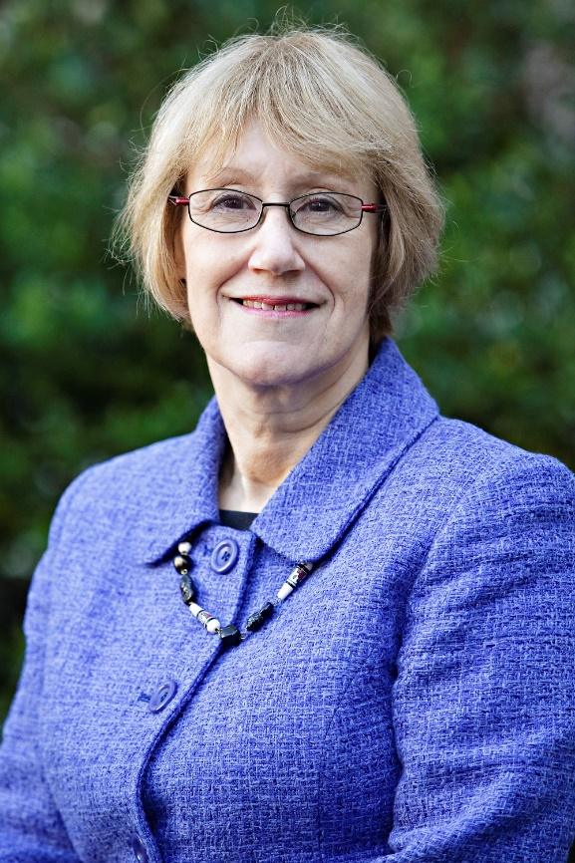
Baroness Ruth Henig CBE CSyI
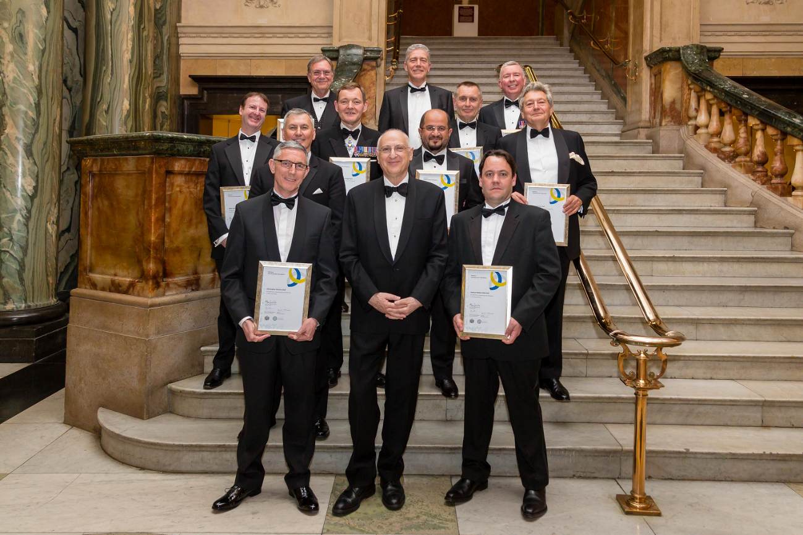

Ends.
MARKETING & PR ENQUIRIES
Rachael Short, Marketing & PR Officer
02476 346 758
rachael@security-institute.org
www.security-institute.org
NOTE TO EDITORS
The Register of Chartered Security Professionals (RCSP) was established under a Royal Charter, issued to the Worshipful Company of Security Professionals (WCoSP) in the UK and launched in 2011. Registrants use CSyP as a post nominal and are called Chartered Security Professionals.

Becoming a Chartered Security Professional is a means of being recognised and continuing to represent the highest standards and ongoing proficiency. It is the gold standard of competence in security.
​
Applications to become Chartered are managed by The Security Institute on behalf of the WCoSP. Licenced organisations are The Security Institute and ASIS UK Chapter 208, who can both mentor and support Chartered Security Professional applicants.
​
The Register of Chartered Security Professionals is recognised across the UK, including by the Security Industry Authority (SIA), the Centre for the Protection of National Infrastructure (CPNI) and membership organisations including the Association of Security Consultants (ASC) and the International Professional Security Association (IPSA).

Visit the RCSP website to learn more about achieving Chartered Security Professional (CSyP) status or email info@charteredsecurityprofessional.org.

