The Security Institute Welcomes Anna Averkiou as Media Advisor
The Security Institute senior leadership team have announced that former BBC journalist, Anna Averkiou, has accepted a position as Board Advisor in the area of media engagement.

An international journalist, part-time journalism lecturer, media consultant and trainer, Anna will bring more than 30 years of experience to her advisory role, listing some of her key skills as reputation management, crisis media management and strategy, broadcast and print journalism, risk mitigation and public speaking. In addition to senior editorial and management roles at the BBC, she also spent several years covering headline stories in the Balkans, Europe, MENA, CIS and SE Asia for WTN (APTN), Visnews (Reuters TV), CNN, Superchannel, MBC, and ABC (US). She regularly teaches, writes and speaks about journalism and media issues - particularly relating to CNI and security - and was Media Advisor to the Panel of the Independent Jersey Care Inquiry into historic child abuse.

Within her consultancy, Anna already works with small to medium sized enterprises and clients in the not-for-profit sector, making her expertise particularly useful for the Institute to improve on their current practices with managing internal press, news and media operations strategy.

Speaking of her appointment as Media Advisor, Anna said; “This sector has traditionally stayed under the press radar - but with today's fast-changing media landscape, it's now more than ever before vital that the right people are providing information and reassurance to the public via different media platforms. I'm looking forward to helping the Security Institute become the go-to place for comment and analysis on key security issues and am delighted to have be asked to come on board”.

Anna was invited by Security Institute Chairman, Dr Alison Wakefield FSyI, who was pleased to add: “I’m delighted that Anna has come on board with us as Media Advisor to help us build the Institute’s profile at the national level. We will be identifying several key areas in which we want to establish a distinct media message, and a number of media-trained representatives of the Security Institute who will present those messages. It is essential that security messaging in the media is authoritative and up-to-date, and with Anna’s help we will be working to build the connections that we need in order to get the Institute onto our screens and into our national press more regularly.”
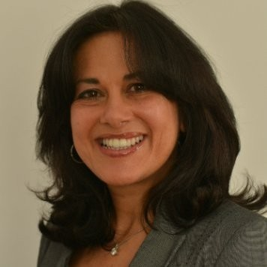
Anna Averkiou, International Media Consultant
Ends.
NOTE TO EDITORS
The Security Institute is the UK’s largest membership organisation for security professionals, with over 2900 members to date, enjoying a range of benefits – including online mentoring, professional development, a members-only LinkedIn group, regional CPD and networking events, London Chamber of Commerce membership and much more. Join us!
MARKETING & PR ENQUIRIES
Rachael Short, Marketing & PR Officer
02476 346 758
rachael@security-institute.org
www.security-institute.org

